Flashing the motherboard firmware:

1. Connect the motherboard to a computer via USB.

2. Enter USB flashing mode:
Simultaneously press and hold the BOOT0 and RESET buttons. Release the RESET button first, then the BOOT0 button.

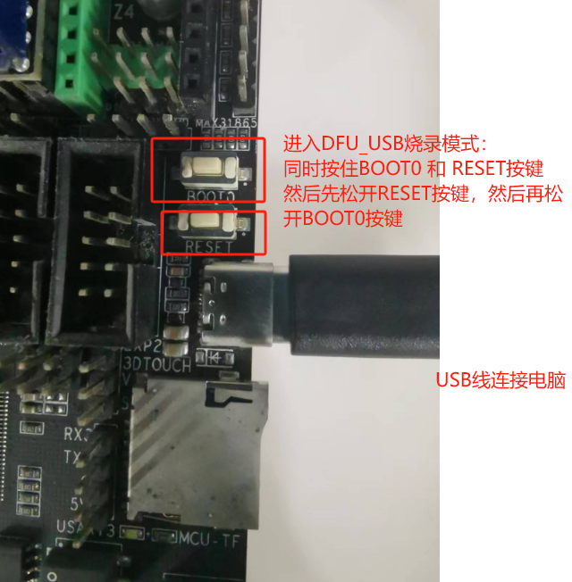

3. Open the STM32Cube Programmer software. Connect the motherboard and select the USB programming port.

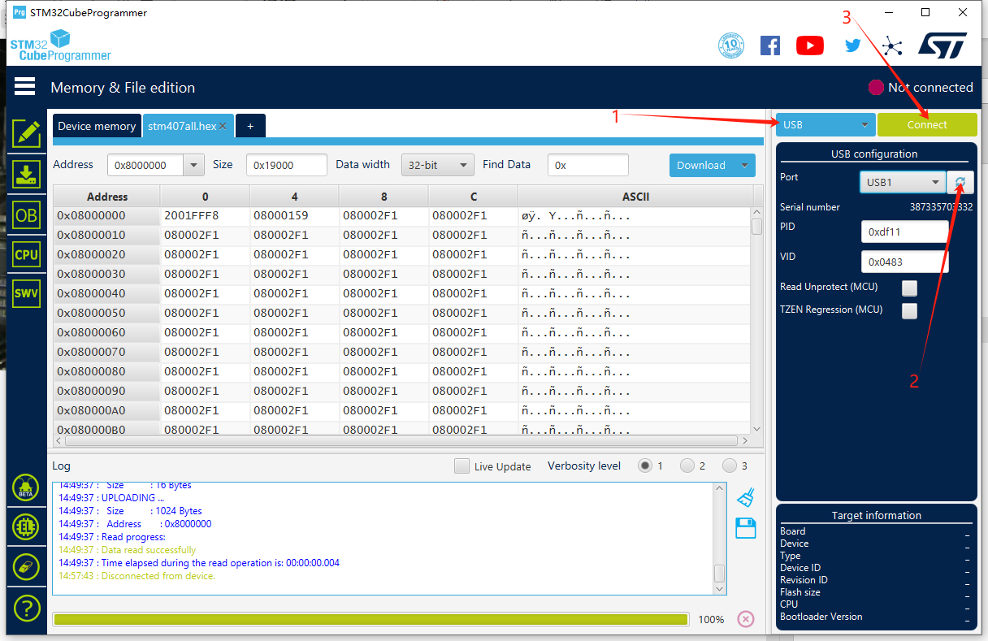

4. Select the mainboard burning file: all_klipper_407.bin starting address 0x0 for burning, and wait for the burning to complete.

